Week 6 Tutorial - Combinational Logic

Outcomes:

An understanding of the use of the truth tables and combinational logic.

To develop skills in making observations from experimental work

To develop skills in relating what you have done with theory.

Introduction: During each of these tasks write a short description of how you went about completing the task. While doing the task write down any observations you made during the task. At the end of the task write down a conclusion (For example: what did the circuit do? Is there something noteworthy about the relationship between the inputs and the output.) In the conclusion in your notes do not worry about repeating what you said in the observations.

Task 1.

In your lab book, copy the logic combination and the truth table below. Then fill in the truth table.

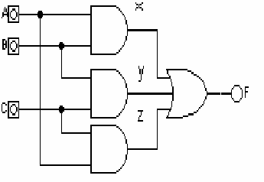

|  |  |  |  |  |  |  |
| --- | --- | --- | --- | --- | --- | --- |
| A | B | C | X | Y | Z | F |
| 0 | 0 | 0 |  |  |  |  |
| 0 | 0 | 1 |  |  |  |  |
| 0 | 1 | 0 |  |  |  |  |
| 0 | 1 | 1 |  |  |  |  |
| 1 | 0 | 0 |  |  |  |  |
| 1 | 0 | 1 |  |  |  |  |
| 1 | 1 | 0 |  |  |  |  |
| 1 | 1 | 1 |  |  |  |  |

Truth table 1

Task 2

In your lab book, copy the logic combination and the truth table below. Then fill in the truth table.

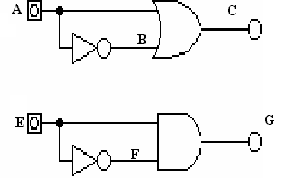

|  |  |  |  |  |  |
| --- | --- | --- | --- | --- | --- |
| A | B | C | E | F | G |
| 0 |  |  | 0 |  |  |
| 1 |  |  | 1 |  |  |

Truth table 2

Relate what you observed to relevant theory.

Task 3

In your lab book, copy the logic combination and the truth table below. Then fill in the truth table.

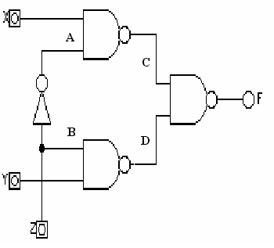

|  |  |  |  |  |  |  |  |
| --- | --- | --- | --- | --- | --- | --- | --- |
| X | Y | Z | A | B | C | D | F |
| 0 | 0 | 0 |  |  |  |  |  |
| 0 | 0 | 1 |  |  |  |  |  |
| 0 | 1 | 0 |  |  |  |  |  |
| 0 | 1 | 1 |  |  |  |  |  |
| 1 | 0 | 0 |  |  |  |  |  |
| 1 | 0 | 1 |  |  |  |  |  |
| 1 | 1 | 0 |  |  |  |  |  |
| 1 | 1 | 1 |  |  |  |  |  |

Truth table 3

Some questions to help with your observations

How does input Z relate to B?

For those that want a challenge: In terms of inputs X, Y, and Z can you an alternative combination of logic gates only using AND, NOT and OR to produce the same output as F.

Task 4

In your lab book, copy the logic combination and the truth table below. Then fill in the truth table.

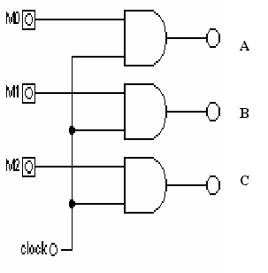

|  |  |  |  |  |  |  |
| --- | --- | --- | --- | --- | --- | --- |
| M0 | M1 | M2 | clock | A | B | C |
| 0 | 0 | 0 | 0 |  |  |  |
| 0 | 0 | 0 | 1 |  |  |  |
| 0 | 0 | 1 | 0 |  |  |  |
| 0 | 0 | 1 | 1 |  |  |  |
| 0 | 1 | 0 | 0 |  |  |  |
| 0 | 1 | 0 | 1 |  |  |  |
| 0 | 1 | 1 | 0 |  |  |  |
| 0 | 1 | 1 | 1 |  |  |  |
| 1 | 0 | 0 | 0 |  |  |  |
| 1 | 0 | 0 | 1 |  |  |  |
| 1 | 0 | 1 | 0 |  |  |  |
| 1 | 0 | 1 | 1 |  |  |  |
| 1 | 1 | 0 | 0 |  |  |  |
| 1 | 1 | 0 | 1 |  |  |  |
| 1 | 1 | 1 | 0 |  |  |  |
| 1 | 1 | 1 | 1 |  |  |  |

Truth table 4

Task 5: The tough one

(a) Construct the truth table (see truth table 5) for the logic combination shown below. C1, C2 and A B are the inputs (in the truth table the inputs should be in that order). G is the output. Show in the truth table all the stages (including D, E, and F).

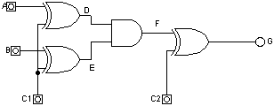

(b) If A and B are the inputs to the set of logic gates and G is the output, what is the effect of the control inputs C1 and C2. Hint: look at the truth table for .A, B and G for each combination of C1 and C2, are they similar to any other logic you have seen.

|  |  |  |  |  |  |  |  |
| --- | --- | --- | --- | --- | --- | --- | --- |
| Inputs | | | |  | | | |
| C1 | C2 | A | B | D | E | F | G |
| 0 | 0 | 0 | 0 |  |  |  |  |
| 0 | 0 | 0 | 1 |  |  |  |  |
| 0 | 0 | 1 | 0 |  |  |  |  |
| 0 | 0 | 1 | 1 |  |  |  |  |
| 0 | 1 | 0 | 0 |  |  |  |  |
| 0 | 1 | 0 | 1 |  |  |  |  |
| 0 | 1 | 1 | 0 |  |  |  |  |
| 0 | 1 | 1 | 1 |  |  |  |  |
| 1 | 0 | 0 | 0 |  |  |  |  |
| 1 | 0 | 0 | 1 |  |  |  |  |
| 1 | 0 | 1 | 0 |  |  |  |  |
| 1 | 0 | 1 | 1 |  |  |  |  |
| 1 | 1 | 0 | 0 |  |  |  |  |
| 1 | 1 | 0 | 1 |  |  |  |  |
| 1 | 1 | 1 | 0 |  |  |  |  |
| 1 | 1 | 1 | 1 |  |  |  |  |

# Truth table 5